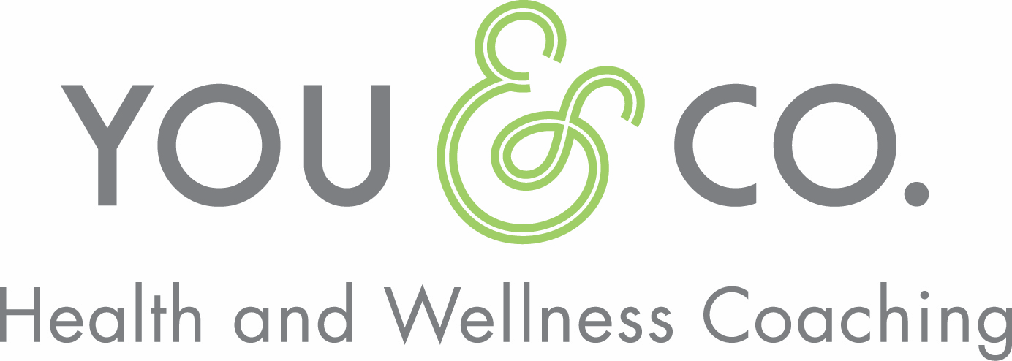

**Coaching FAQs**

**Q: So, you’re a life coach, right?**

A: Nope! I’m a health and wellness coach. While there can be some overlap in what life coaches and health and wellness coaches do, I’m specifically focused on helping you take practical actions to help you achieve better health and wellness. Health and wellness are broad terms, so the framework I use to talk about health and wellness is the Emory Health Compass.

**Q: What is the Emory Health Compass?**

A: The Emory Health Compass model recognizes that all parts of our lives are interconnected. Each of the 8 broad areas of the Emory Health Compass (Food, Physical Activity & Relaxation, Relationships, Meaningful Work, Mindful Awareness, Environment, Complementary Care, and Conventional Medical Care) impacts our overall health and wellness. The emphasis on an individual area may change over time, but each is important in determining our overall health and wellness.

**Q: Are you just going to give me more advice?**

A: Research supports the use of motivational interviewing techniques in health coaching to create lasting behavior change and improve health and wellness. I employ this model of coaching. Motivational interviewing is a client-focused way of working with clients to get results. It’s not about what *I* want you to do; it’s about what *you* want to do to improve your own health and wellness. So, while I may give you information or tips from science-based resources, or advice related to a particular inquiry you may have, the process is much more collaborative than a prescriptive, advice-giving model.

**Q: What is motivational interviewing?**

A: Motivational interviewing employs non-judgmental questioning, utilizing open-ended questions, active listening, and reflections on what you, the client, have said, in order to explore your values and motivations, clarify meaning, uncover obstacles to success, and create a sustainable action plan for better health and wellness.

**Q: But I’m really looking for someone to just tell me what to do. Can’t you just give me a quick and easy solution?**

A: Simply put, solutions that are client-driven­­––rather than solutions suggested or mandated by someone else––are more successful long-term. Why? Because ultimately clients are the experts on themselves and their own lives, and they often instinctively know what will work best to create positive change in their own lives. They just may need some help in uncovering what that is, and following through long-term.

Think of it this way: how many times has a doctor given you advice to lose weight or eat better? How many times have you tried a weight-loss diet program only to end up right back where you started? Usually this is because the “solution” is pre-determined by someone else, and it doesn’t take into account how you actually live. That means it won’t integrate well into your life or help you build the skills you need to implement change long-term. That’s the difference between the prescriptive model of health and wellness we’re used to, and the collaborative model of coaching, which can more successfully lead to long-lasting positive outcomes.

**Q: So, if I have all the answers inside me, what do I need a coach for?**

A: Good question! Often there are issues or problems that you just can’t seem to get past. Perhaps you need structure, accountability, or an unbiased, supportive ear to help you work through a particular challenge. There may also be deeper internal or external conflicts, unexamined values, or other obstacles that make achieving change and optimal wellness difficult. A coach can help you explore deeper values, overcome ambivalence, and improve your health and wellness for the long term.

**Q: OK, got it. So what should I expect in a health and wellness coaching session?**

A: Coaching sessions are client-led, which means you determine what you’d like to tackle in each session­­ - I’ll follow your lead. As your coach, I’ll use techniques from motivational interviewing to help in your exploration of your values. We’ll work toward developing an action plan using SMART goals that can help you make positive, lasting change in your life; change that is determined by you, for you. I’ll also provide accountability to help keep you on track toward your goals. And every now and then if you want some advice, I’ll even provide that too.

**Q: Where did you learn all this stuff?**

A: I’m a graduate of the Emory University Health Coach Program, an evidence-based, ICHWC-approved (International Consortium for Health and Wellness Coaches) program; a graduate of the Precision Nutrition Level 1 Nutrition Coaching Program, a science-based program (no detoxes, restrictive diets, or magical thinking here); I’ve earned a Personal Training certification through the National Academy of Sports Medicine (NASM); and I’m a National Board Certified Health and Wellness Coach (NBC-HWC).

Q: What was your previous professional background?

A: For many years I was a retail buyer for department stores, ecommerce and specialty retailers, including West Elm. Most recently I was a Sales executive at several well-known luxury brands in the Tabletop, Home, and Gift industry, and I occasionally consult in the retail industry.